Entry Form
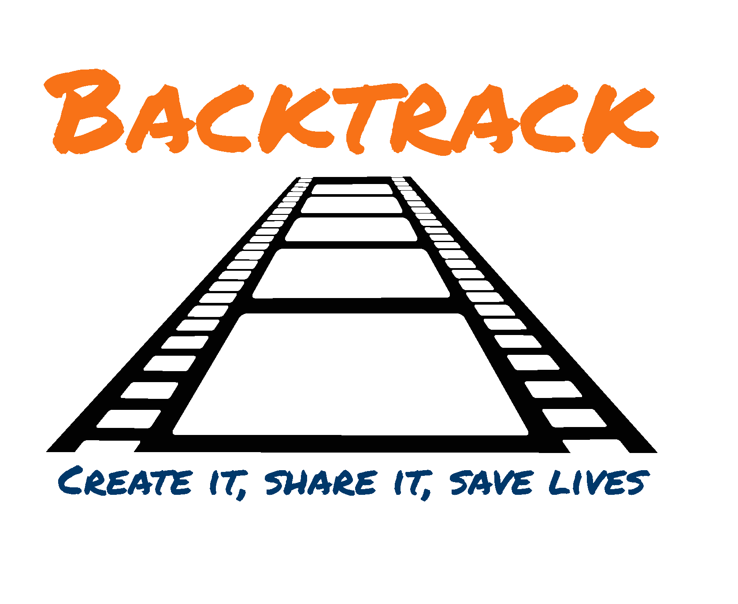

Please send:

your entry (film/storyboard/song/script)
- your completed entry form and
- your completed media consent form
to backtrack.competition@gmail.com or via WeTransfer
by 11.59 p.m. on Wednesday 30th September 2020.

www.downtheline.org.uk/projects/backtrack

Please tick which categories you are entering (you can enter more than one category)
Video | ☐ |  | Storyboard | ☐ |  | Script | ☐ |  | Song | ☐ |  | School/group entry | ☐ |  | Impact on social media | ☐

Name | Click or tap here to enter text. |  | Age | Click or tap here to enter text.
Parent/carer’s name  and contact telephone number |  | Click or tap here to enter text.
Parent/carer’s e-mail address |  | Click or tap here to enter text.
Teacher/group leader’s name School/group name and address (if entering school/group category) |  | Click or tap here to enter text.

How useful did you find the competition information provided by us and the weblinks
signposting you to useful resources online?
Very useful | ☐ |  | Quite useful | ☐ |  | Didn’t use it | ☐

How did you find out about this competition?
Click or tap here to enter text.

I have read and agree to all the terms and conditions of the Backtrack Competition 2020  - I can confirm that the entry adheres to the theme and contains a positive message.  - I have provided correct contact details. | - Any music used is compliant with the competition rules and regulations concerning copyright.  - I have enclosed my media consent form (remember to send one for each student in a school group).
Parent / carer’s name (please print):  Click or tap here to enter text. | Teacher/group leader’s name for school/groups only (please print):  Click or tap here to enter text.
Signature | Signature
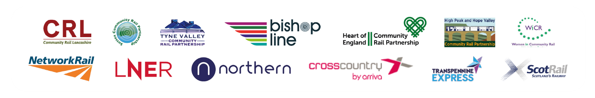
Entry_ Form_Word_030720
Media Consent Form

Please send:

your entry (film/storyboard/song/script)
- your completed entry form and
- your completed media consent form
to backtrack.competition@gmail.com
www.downtheline.org.uk/projects/backtrack
or via WeTransfer by 11.59 p.m. on Wednesday 30th September 2020.
*How are images used?

We use images in a range of materials to promote community rail as a whole and to illustrate particular areas of our work. This includes (but is not limited to) publicity materials such as leaflets, brochures, posters, newspapers, local and trade media, magazines, tv programmes, educational materials, social media and publications for the internet.

As a parent/primary carer of _______________________________________ I hereby agree to:
(Child’s name)
• Allow railway industry stakeholders (such as community rail partnerships and train operating companies) to use and reproduce photographs, images and video footage of my child as outlined above*.
• Allow railway industry stakeholders to securely store images and video footage of my child for future use. This means dissemination of this year’s competition, future promotion of this competition, annual reports and our school outreach work. This may be in print, on our website or social media platforms.

_______________________________________________ _______________________________
Parent/carer signature Date

As the young person whose image or video footage may be used by railway industry stakeholders you agree to:
• Allow railway industry stakeholders to use photographs, images and video footage of myself as outlined above*.
• Allow railway industry stakeholders to securely store images and video footage of myself for future use.

_______________________________________________ _______________________________
Young person signature Date

Railway industry stakeholders agree to:
• Only use images of young people with the consent of their parent/carer.
• Store images and video footage of young people securely.
• Use images and video footage of young people as set out on the consent form.
• Never fully identify a young person in conjunction with an image. We may use partial information such as a first name and school/organisation.
• Remove images or footage of young people upon written request by their parent/carer. Online photographs will be removed immediately and printed or published footage will be removed for subsequent print runs and editions.
For more information on how CRL handles data, please refer to our privacy policy.

Media_Consent_ Form_Word_030720

